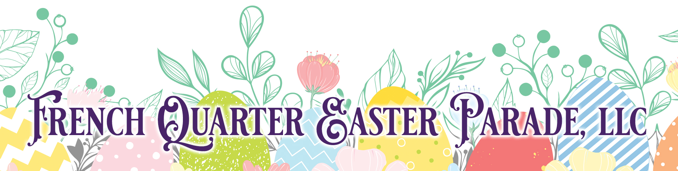

New Orleans' Tradition Celebrates its 39th Year!
On March 31st, 2024, the Easter Sunday morning celebration will begin at 11:00 AM with a Silent Auction, music and Hat Contest at the Omni Royal Orleans Grand Ballroom, 621 St. Louis Street. This will be "no ordinary hat contest"…local notables will be the judges!

At 1:00 PM, the French Quarter Easter Parade will assemble at the corner of Royal and St. Louis Streets (Omni Royal Orleans Hotel) and begin a path through the heart of the French Quarter complete with colorful floats, marching bands, beads and more! Following the parade and back at the Omni Royal Orleans Hotel, there will be a lavish private brunch where the LIVE and SILENT auction will continue AND include dancing to the marvelous music of David Cook and the Yat Pack band.

— RESERVATION FORM —

Please select Ticket(s) Option, Fill Out the Form Below, Attach and Mail Payment no later than February 23, 2024.

A. Easter Brunch and Parade Gala ($400/ticket) No. of Tickets _____________
B. Easter Brunch Gala Only ($225/ticket) No. of Tickets _____________
C. Children's Brunch (ages 10 and under)
and Parade Gala ($300/ticket) No. of Tickets ______________

PLEASE PRINT

Name Phone Number
Address City/State/Zip
E-mail

If you would like to ride with another person/couple/family, please list name(s) below:

Make Checks Payable and Mail Payments with Form to:
The French Quarter Easter Parade LLC • 1301 Christopher Court • Metairie, LA 70001

